**GCE “O” Levels Paper Parodies™**

**World Matters 2025**

**Paper 1**

Name: _________________________________________________

Class: ___________ Date: __/__________/____

Subject: World Matters 2025

Duration: 1 h 30 min

Marks Awarded: ___/40

**INSTRUCTIONS TO CANDIDATES:**

* There are two sections in this paper:
  + Section A: Case Study
    - Answer ALL questions on the foolscap papers provided. Indicate clearly the QUESTION NUMBER of the questions you are answering.
    - This section is worth a total of 30 marks.
  + Section B: Free Response Questions
    - Answer 1 question on the foolscap paper provided. Indicate clearly the QUESTION NUMBER of the question you are answering.
    - This section is worth 10 marks.
* Correction Tape and highlighters are NOT allowed.

© 2025 Paper Parodies™. All rights reserved. No part of this paper may be reproduced in any form, without the permission of Paper Parodies™ and all owners of 3rd party content. Terms and Conditions apply.

Copyright acknowledgements are written at the very back of this paper.

**This paper consists of 6 printed pages.**

**Section A: Case Study**

Background Information:

On 2nd April 2025, the president of the United States (referred to as “USA” or “US”), Donald Trump, announced tariffs and reciprocal tariffs on 185 countries and territories in the world in an executive order.

“Tariffs” are taxes imposed by a country on imported goods and services.

“Reciprocal Tariffs” are tariffs from a country that are imposed on other countries at the same rate that those countries impose on that country. For example, if Country X imposes a 25% tariff on Country Y, Country Y may impose a reciprocal tariff of 25% on Country X.

This announcement was met with many responses from all parts of the world and many immediate effects throughout the world, especially as the US is integral in global trade. View the following sources to see the reactions of different parties to see if the world generally responded positively or negativity on the tariffs.

Source A: An extract from Trump’s tariff announcement on 2nd April 2025.

This is one of the most important days in my opinion in American history. It's our declaration of economic independence, for years hardworking American citizens were forced to sit on the sidelines as other nations got rich and powerful, much of it at our expense. But now it's our turn to prosper and in doing so use trillions and trillions of dollars to reduce our taxes and pay down our national debt and it'll all happen very quickly.

With today's action we are finally going to be able to make America great again, greater than ever. Jobs and factories will come roaring back into our country and you[‘ve] see[n] it happening already. We will supercharge our domestic industrial base, we will pry open foreign markets and break down foreign trade barriers and ultimately more production at home will mean stronger competition and lower prices for consumers. This will be indeed the Golden Age of America.

Source B: A meme about the tariffs posted on the social media platform “X”. This post comes after the US placed 10% tariffs on Heard and McDonald Islands, a collection of uninhabited islands owned by Australia, located about two-thirds of the way from Madagascar to Antarctica. Only penguins are present on the island.

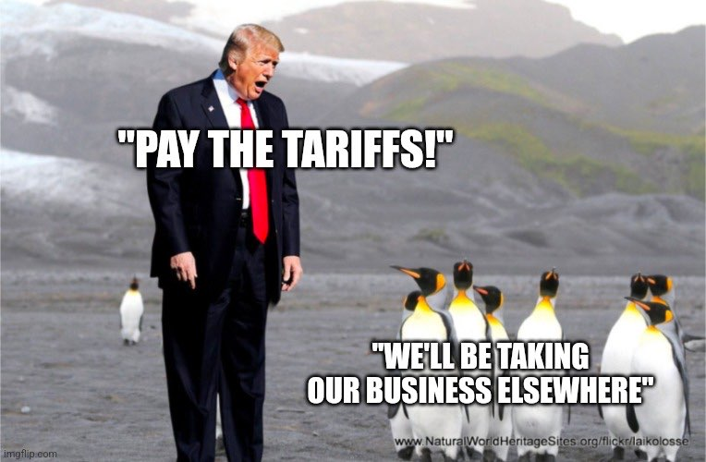

Source C: An extract from a message from Singapore’s current Minister for Trade and Industry, Mr Gan Kim Yong, on the 10% tariffs placed on Singapore by the US. The US-Singapore Free Trade Agreement (abbreviated as “FTA”) is a bilateral agreement that allows free trade of goods between the US and Singapore.

We are naturally disappointed that despite our strong and longstanding economic and commercial relationship with the US under the US-Singapore Free Trade Agreement, we are also subject to the same 10% baseline tariffs.

The US-Singapore FTA has been a very important FTA for both countries and has benefited the US significantly. US imports to Singapore have enjoyed zero tariff[s] for more than two decades and they have also enjoyed a significant substantial trade surplus with Singapore amounting to $30 billion, so I think this is something that is important and we are of course naturally disappointed.

Source D: An extract from an article about Vietnam’s response to the 46% reciprocal tariffs imposed on them by the US.

The country's [Vietnam’s] [Ministry of Industry and Trade](https://en.wikipedia.org/wiki/Ministry_of_Industry_and_Trade_(Vietnam)) stated that Trump's 46% reciprocal tariff is "unfair" and "lacking scientific basis"…

…Meanwhile, [Prime Minister](https://en.wikipedia.org/wiki/Prime_Minister_of_Vietnam) [Phạm Minh Chính](https://en.wikipedia.org/wiki/Ph%E1%BA%A1m_Minh_Ch%C3%ADnh) summoned an emergency meeting with [his cabinet](https://en.wikipedia.org/wiki/Government_of_Ph%E1%BA%A1m_Minh_Ch%C3%ADnh) and assigned two of [his deputies](https://en.wikipedia.org/wiki/Deputy_Prime_Minister_of_Vietnam) to head a rapid response [task force](https://en.wikipedia.org/wiki/Task_force) and a government's special envoy to deal with the American administration. In another move, the [General Secretary of the Communist Party of Vietnam](https://en.wikipedia.org/wiki/General_Secretary_of_the_Communist_Party_of_Vietnam) [Tô Lâm](https://en.wikipedia.org/wiki/T%C3%B4_L%C3%A2m" \o "Tô Lâm) has made a phone call with Donald Trump to offer a Vietnamese "0%" tariff on American goods in exchange for lowering and eliminating tariffs against Vietnam, having Trump publicly expressed appreciation.

Source E: An extract from an article about Australia’s response to the 10% tariffs imposed on them by the US.

[Australian Prime Minister](https://en.wikipedia.org/wiki/Prime_Minister_of_Australia) [Anthony Albanese](https://en.wikipedia.org/wiki/Anthony_Albanese) stated that the United States' implementation of 10% tariffs on [Australia](https://en.wikipedia.org/wiki/Australia) had "no basis in logic," arguing that "a true reciprocal tariff would have been zero percent". He described the action as "not the act of a friend", but indicated Australia would not immediately impose retaliatory measures.

QA1. From Source A, what can you infer about how Trump views the tariffs? Explain your answer. (5m)

QA2. From Source B, why was the meme posted online? (8m)

QA3. From Source C, what can you infer about Singapore’s views on the tariffs? Explain your answer. (4m)

QA4. “The Vietnamese government is worried that the tariffs placed by the US on them will have a significant effect on Vietnam’s economy.”

From Source D, how far do you agree with this statement? Explain your answer. (7m)

QA5. Study Sources D and E. How far does Source E agree on Source D about the tariffs imposed on them? Explain your answer. (6m)

**End of Section A**

**Section B**

Answer ONE question from this section.

**This question is about the 25% tariffs initially placed on Mexico by the US to stop the flow of illegal immigrants and drugs into the US.**

QB1. “The tariffs were effective in stopping the flow of illegal immigrants and drugs into the US.”

How far do you agree with this statement? Explain your answer. (10m)

**This question is about the extension of the deadline of the TikTok ban by 75 days by Donald Trump in his first day of office.**

QB2. How effective was the TikTok ban in achieving its goal by the end of the 75 days? Explain your answer. (10m)

**This question is about the 7.7 magnitude 2025 Myanmar Earthquake that occurred on 28 March 2025.**

QB3. “The international community assisted with much-needed financial aid and recovery efforts in Myanmar.”

How far do you agree with this statement? Explain your answer. (10m)

**End of Section B**

**Copyright Acknowledgements**

**The following information was taken from these sources:**

Source A: Referenced and transcribed using a YouTube video titled “Trump's tariffs: Announcement Highlights” by channel “FOX 2 Detroit”. https://www.youtube.com/watch?v=uAKzmKBAWuM

Source B: Taken from a “X” post by Pekka Kallioniemi. https://x.com/P_Kallioniemi/status/1907759698171846783?ref_src=twsrc%5Etfw%7Ctwcamp%5Etweetembed%7Ctwterm%5E1907759698171846783%7Ctwgr%5Eb3c7ff68a27824ce5a7524b21036c8172333c1ca%7Ctwcon%5Es1_&ref_url=https%3A%2F%2Fwww.businessinsider.com%2Fpresident-trump-liberation-day-tariffs-reactions-memes-2025-4

Source C: Referenced and transcribed using a YouTube video titled “Singapore disappointed by Trump's tariffs but won't retaliate with import duties: Gan Kim Yong” by channel “CNA”. https://www.youtube.com/watch?v=qND2sxEtcTg

Source D and E: Taken from a Wikipedia Article titled “Donald Trump's Liberation Day speech”, from the section “Tariff Responses – International”. https://en.wikipedia.org/wiki/Donald_Trump%27s_Liberation_Day_speech#International

© 2025 Paper Parodies™. All rights reserved. No part of this paper may be reproduced in any form, without the permission of Paper Parodies™ and all owners of 3rd party content. Terms and Conditions apply.

By taking this paper, you agree to follow the rules and regulations set out by the examination board, and understand that failure to do so may result in consequences, including but not limited to, a permanent ban from taking future examinations, being awarded “0” for the exam, expulsion from the examination venue and legal action due to an offence committed under section 415 of Singapore’s Penal Code 1871.